Call Coach Lab v1 — User Journey Storybook

A role-by-role, screen-by-screen adventure through onboarding, call QA, outcomes, contact journeys, and insights.
Scope: Web app • Upload + Exotel + Twilio • Hindi/English/Punjabi • Scoring SLA < 5 minutes.

Version: v1.0 (working) • Audience: Design + Engineering + Founders + Investors • Confidential

0) How to read this doc (and why it’s written like a story)
Call Coach Lab exists for a simple reason: lead-based SMBs lose money in places they can’t see. Calls happen. Outcomes are guessed. Training is inconsistent. Everyone argues about marketing.
So we’re writing this like a story, because stories reveal friction. And friction is what designers and engineers are here to delete.
Each scene has four layers:
- 🎭 Story: what happens in the real world.
- 🖥️ What the user sees: key screens, interactions, and UI states.
- 🧠 What the system must do: data, logic, automation.
- 🧪 Edge cases: how reality tries to break the product.
If you only remember one rule: **every score must be evidence-first** (timestamp + snippet) and the system must be allowed to say **Unclear**.

1) The cast (personas)
We build for three humans. If any of them hate the product, we lose.

Aman — Admin/Owner
- Wants: visibility into where leads leak, and control over the system.
- Pain: spends money on marketing but can’t prove what happens on calls.
- Success looks like: fewer wasted leads + stable bookings + clear source performance.

Priya — Manager
- Wants: a daily QA workflow that doesn’t require listening to everything.
- Pain: rep performance depends on 1–2 star agents; coaching doesn’t scale.
- Success looks like: quick reviews, consistent scripts, team-wide improvement.

Sarah — Agent
- Wants: fair feedback that helps her book more consults.
- Pain: vague coaching, random criticism, no clear next step.
- Success looks like: 1–2 fixes per call, tied to exact timestamps.
Throughout this doc, we’ll follow Aman, Priya, and Sarah as calls flow in, get scored, get reviewed, and finally show up as insights.

2) The world map (core objects) — explained like you’re onboarding a new intern
These objects are the foundation. If we get them right, reporting is accurate and UX stays simple. If we get them wrong, everything becomes a spreadsheet fight.

Workspace
A Workspace is one business unit using Call Coach Lab (one clinic/branch in v1). It contains users, teams, scorecards, calls, contacts, and settings.
v1 constraint: **no multi-location**. One workspace = one location.

User (Admin / Manager / Agent)
Users belong to a workspace and have a role:
- Admin: setup + permissions + scorecards + integrations + exports.
- Manager: daily QA workflow, overrides, team insights, actions.
- Agent: receives evaluations, acknowledges, sets call outcomes, requests clarification.

Team
Teams are optional groupings of agents (Front Desk, Consultants, Follow-up). Teams make reporting and filtering useful for real clinics.

Call
A Call is the raw event we audit. In v1, a call must have a recording (audio). Every call can also have:
- Transcript (auto-generated; multi-language)
- Speaker labels (Agent vs Prospect at minimum)
- Metadata: agent, timestamp, duration, source/campaign, call type, scorecard used
- Score output: per-criterion pass/fail/unclear + confidence + evidence timestamps
- Agent-set call outcome (e.g., Booked consult / Not fit / Spam)
- Flags (e.g., price objection, competitor mention, potential outcome mismatch)

Contact (the customer journey object)
A Contact links multiple calls from the same phone number into a timeline. This matters because customers rarely convert in one call. They call, follow up, reschedule, ask again, and only then book/pay.
In v1 the Contact key is the **normalized phone number**. A Contact stores:
- A timeline of calls (inbound + follow-up + consult).
- Current stage (e.g., New → Follow-up → Booked → Converted).
- Final outcome (the ‘truth’ after the journey ends).
- Attribution payload (UTMs/campaign/source) when available.
This is how we avoid flawed reporting when outcomes differ by scorecard: we report both **per-call outcomes** and **final contact outcomes**.

Scorecard (definition of “good”)
A Scorecard is a structured checklist of behaviors that predict good outcomes for a specific call type (Inbound, Follow-up, Consult).
A scorecard includes sections (Opening, Qualification, Objections, Close, Compliance) and criteria that can be scored automatically. It also defines thresholds and critical fails.

Outcomes (two kinds)
Outcomes exist at two levels:
- Call Outcome (per scorecard): set by the Agent for each call. Fully custom per scorecard.
- Final Outcome (per contact): the final truth about the customer journey. Fully custom per business.
To connect the two, we use mapping rules (next).

Outcome Mapping Rules
Mapping rules translate a call outcome into a contact stage change or final outcome update. Example:
- Inbound outcome = ‘Booked consult’ → Contact stage becomes ‘Booked’.
- Consult outcome = ‘Paid’ → Final outcome becomes ‘Converted’.

Attribution (what it is, and why we care)
Attribution is how we connect calls to marketing sources/campaigns. In human terms: it answers, “Where did this lead come from?”
We support attribution because owners optimize marketing based on results. If we track only call volume, we end up rewarding spam. Instead we report **quality-adjusted trends** by source/channel (v1 does not require cost).
Attribution can arrive from multiple places: Upload CSV fields, Exotel/Twilio metadata, lead metadata imports (from CRM/forms), and manual edits.

Exotel and Twilio (what these integrations mean)
Exotel and Twilio are call/telephony systems that can store call recordings and metadata. When a clinic uses them, calls can flow into Call Coach Lab automatically instead of manual uploads.
In v1 we support:
- Upload + CSV mapping (fastest to start).
- Exotel integration (auto-ingest recordings).
- Twilio integration (auto-ingest recordings).

Evidence (why the product is trusted)
Evidence is a transcript snippet + timestamp (and audio at that moment). Every score must cite evidence. No evidence → ‘Unclear’.

3) The loop (the thing the whole product is designed to make easy)
Aman buys leads. Rohan calls. Sarah answers. Priya hopes for the best.
Call Coach Lab turns hope into a repeatable loop:
- Calls arrive (Upload / Exotel / Twilio).
- Transcript + speaker labels appear (Hindi/English/Punjabi).
- AI guesses call type + selects scorecard (overrideable).
- AI scores the call with evidence + confidence + Unclear.
- Calls route into QA Queue based on rules (low score, unclear, critical fails, triggers, new reps, random sample).
- Manager reviews fast using evidence jump points, overrides if needed.
- Agent receives evaluation, acknowledges, and gets one concrete next action.
- Agent sets call outcome; AI flags mismatches.
- Contact timeline updates; final outcomes become measurable.
- Insights update: source/channel trends, QA trends, Voice of Customer.
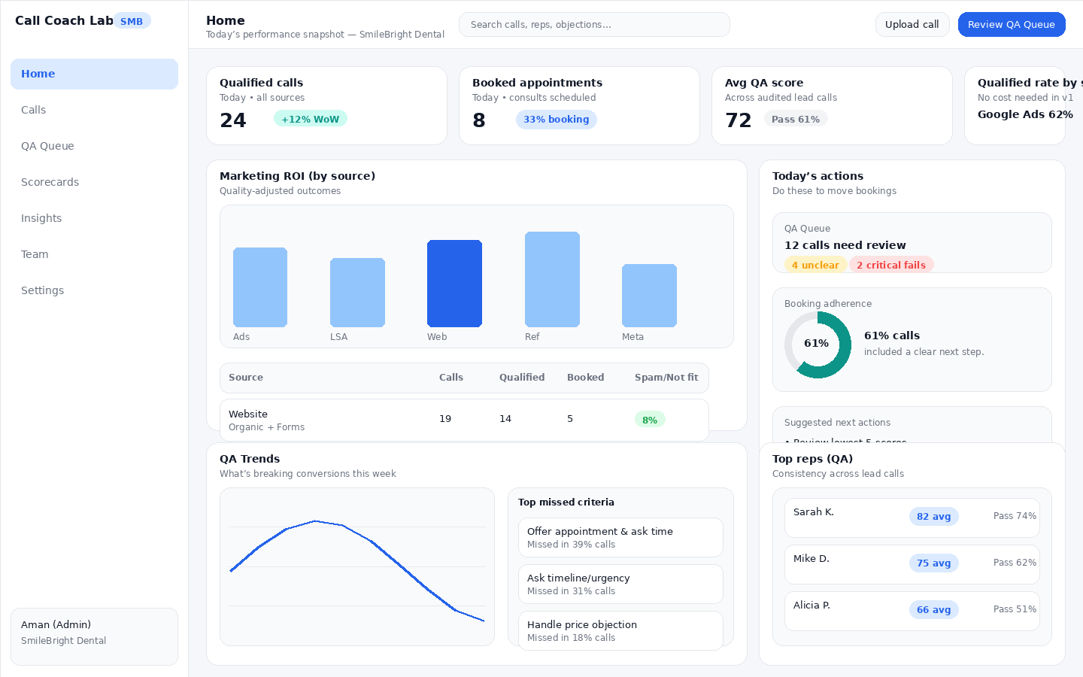
Manager Home Dashboard — quick snapshot + actions.

4) Admin Journey — Aman vs. The Setup Monster
Aman is not buying software for fun. He wants to stop wasting leads and finally know whether the leak is marketing or call handling.

Scene A1 — Onboarding Wizard (connect calls fast)
Goal: get to ‘first scored call’ in one sitting.
- Create workspace (business type, timezone, language).
- Invite team (Managers, Agents) and optionally create Teams.
- Connect calls via Upload + CSV, Exotel, or Twilio.
- Publish at least one scorecard.
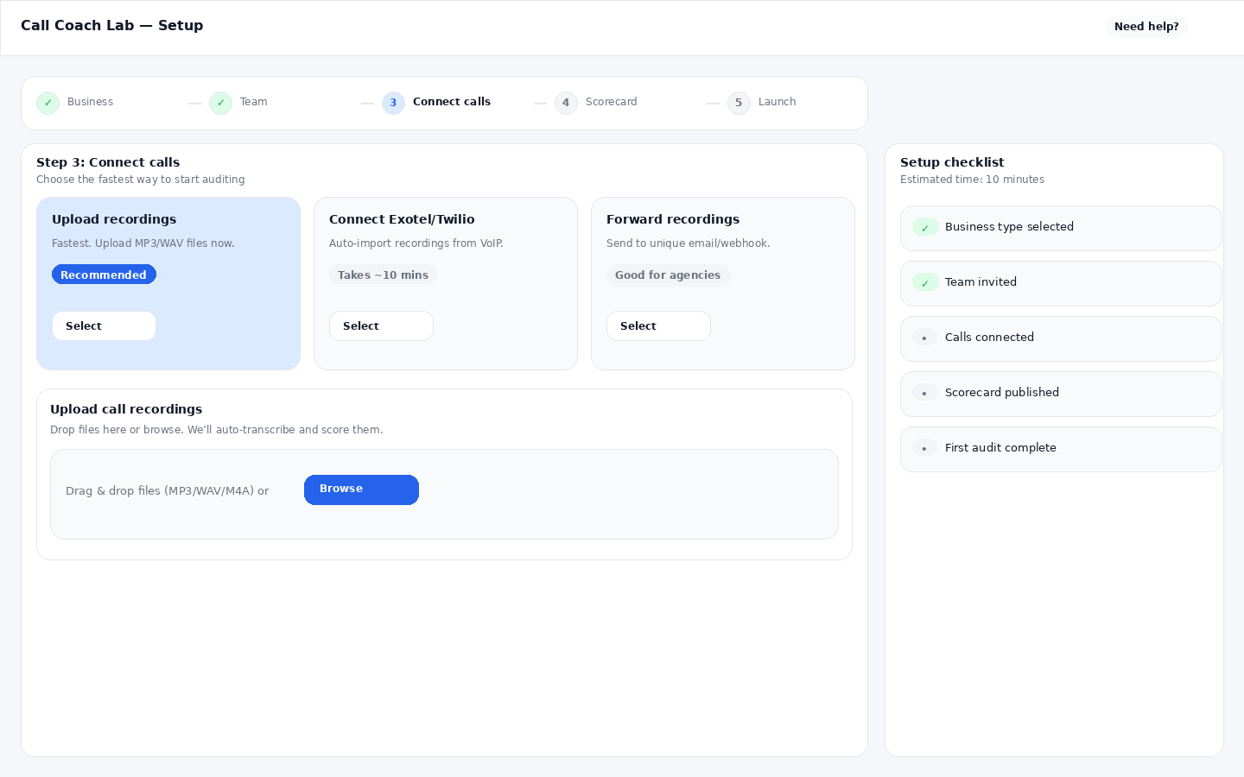
Onboarding Wizard — Step 3: Connect calls.

Scene A2 — Upload + CSV (the fastest v1 path)
Upload includes audio + CSV mapping so calls are immediately usable for QA and reporting.
The CSV connects audio files to metadata such as agent name, date/time, source/channel, campaign/UTMs, call type, caller number, and optional pre-filled outcomes.
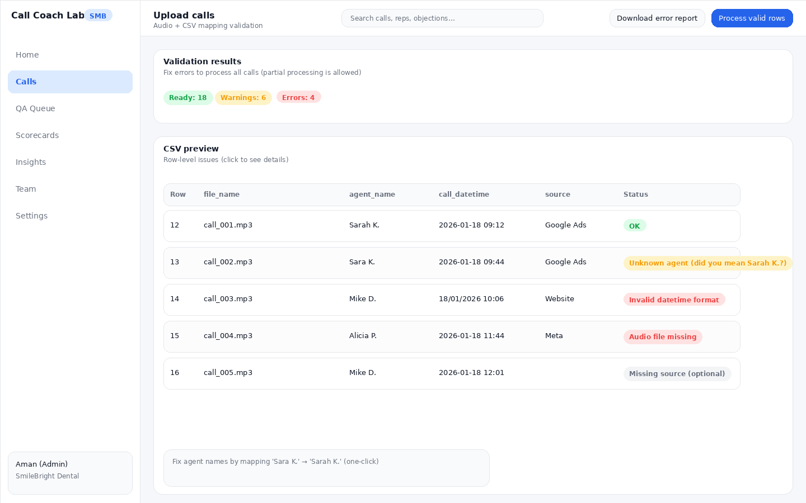
Upload Validation — partial processing is allowed; row-level errors are explicit.

Scene A3 — Integrations: Exotel + Twilio
When Exotel/Twilio is connected, recordings are auto-ingested. If the integration can’t determine the agent identity reliably, calls still ingest as ‘Unassigned’ and can be mapped once.
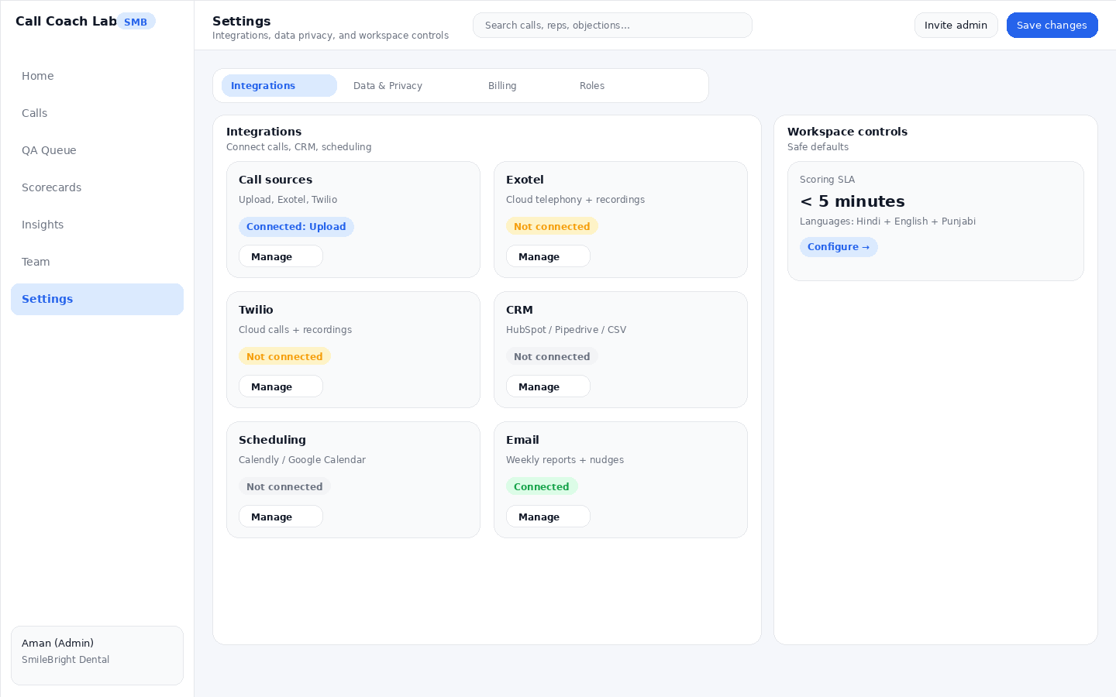
Settings → Integrations — upload + Exotel + Twilio.
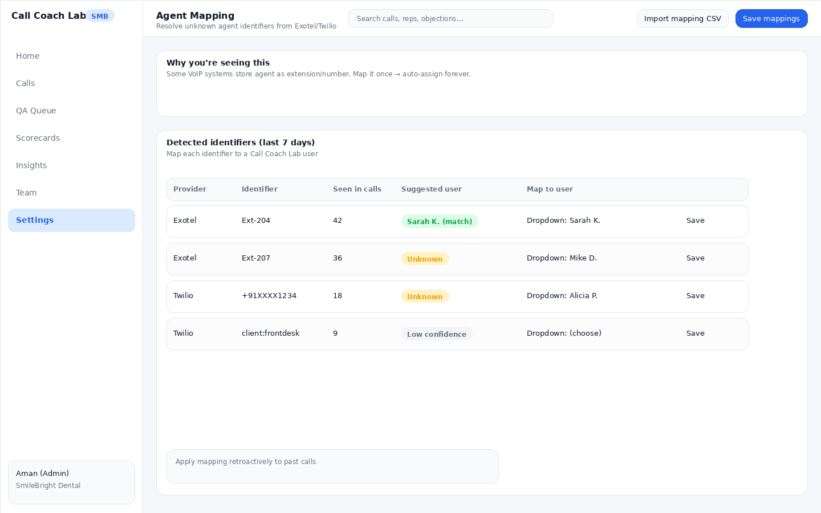
Agent Mapping Table — map extension/identifier to an agent user (one-time setup).

Scene A4 — Attribution setup (UTMs/campaign + manual)
Attribution is how we connect calls to marketing sources/campaigns. In v1 we report trends by source/channel (no cost required).
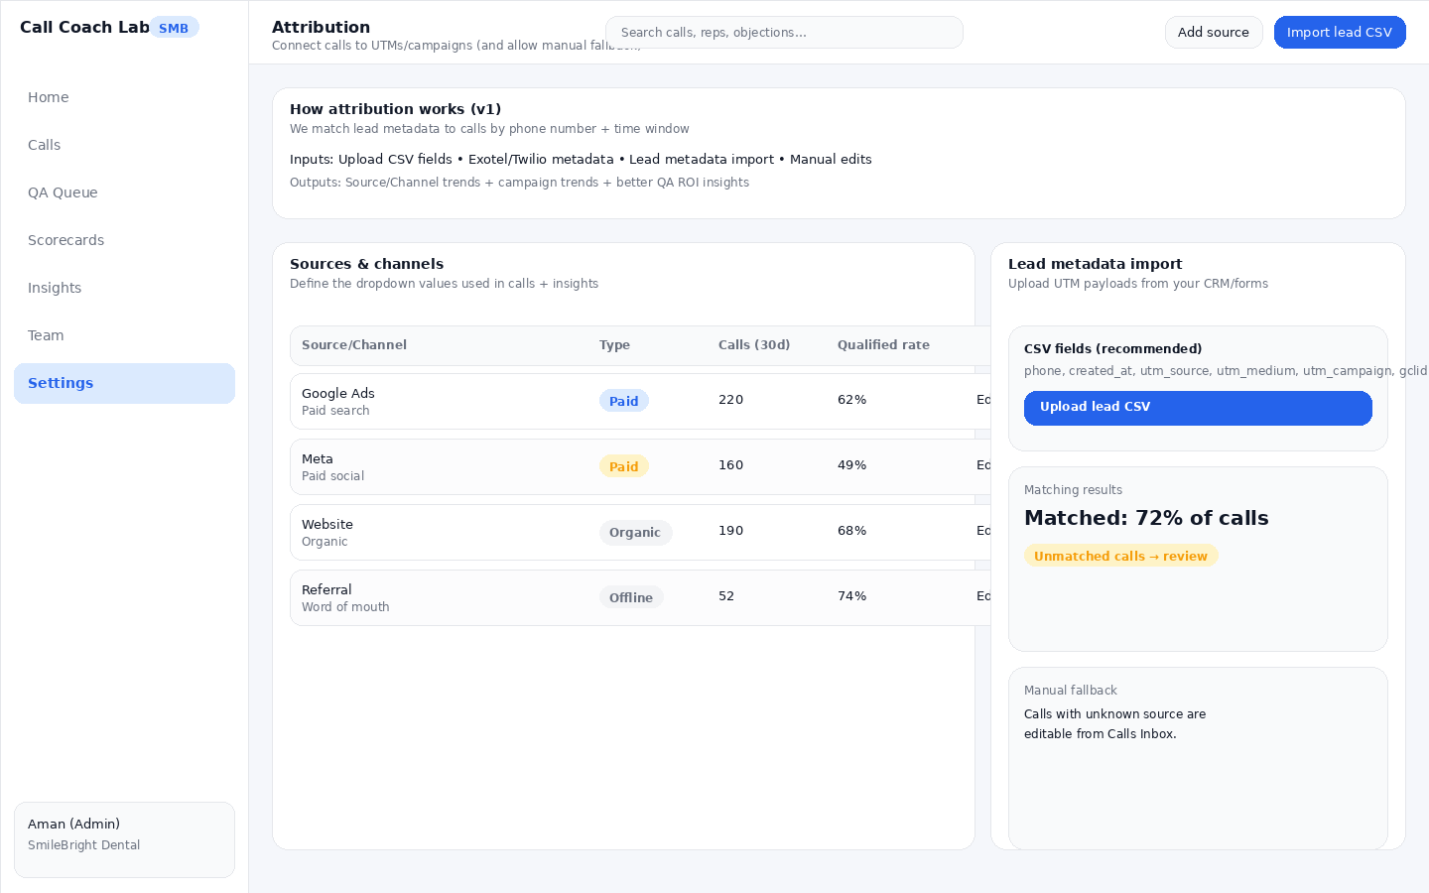
Attribution — import lead metadata + define sources + allow manual edits.

Scene A5 — Scorecards + outcomes + journey mapping
Aman sets up multiple scorecards (Inbound, Follow-up, Consult). Each scorecard can have its own outcome set. Contact final outcomes remain consistent across the whole journey.
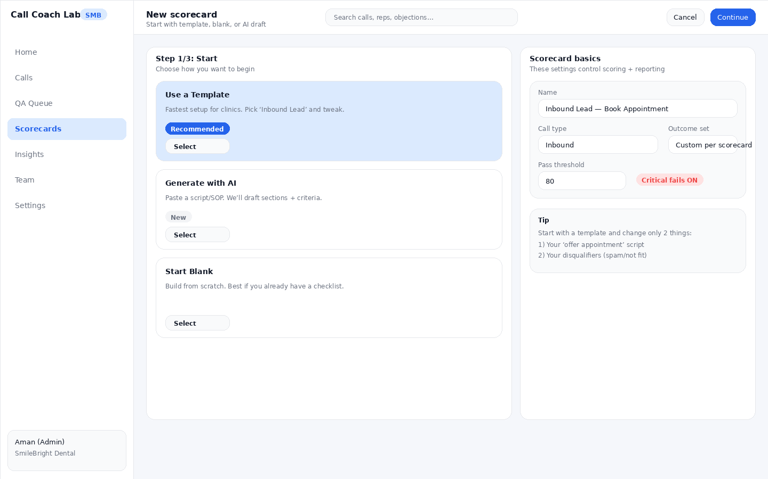
Scorecard Builder — Step 1: start with template / blank / AI draft.
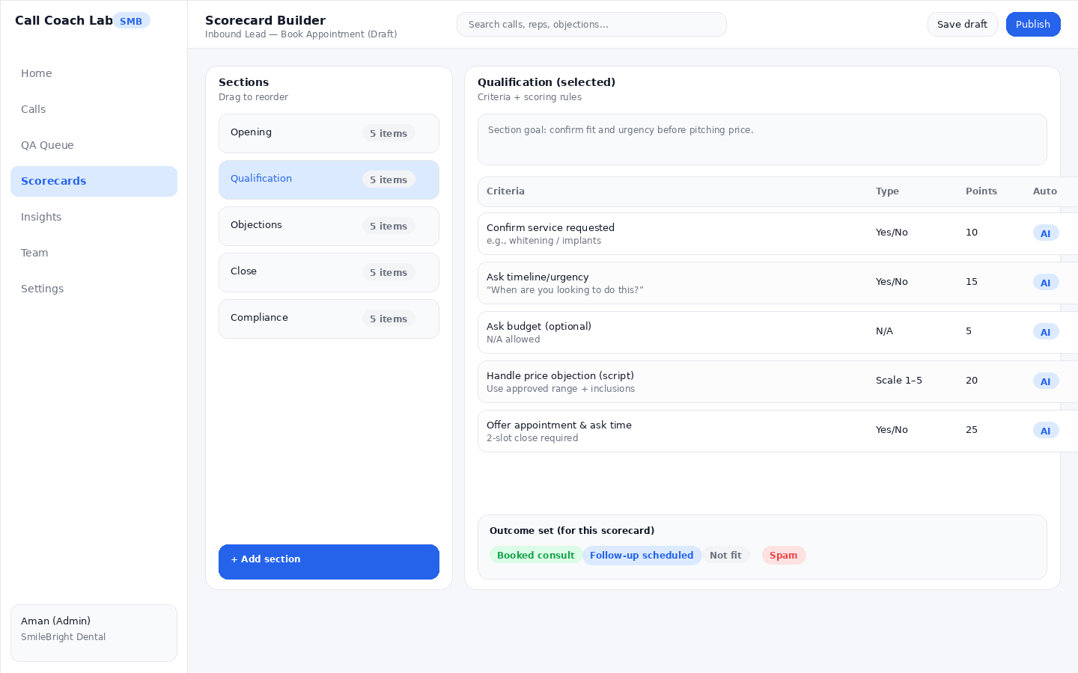
Scorecard Builder — editing criteria, points, and outcomes for one section.
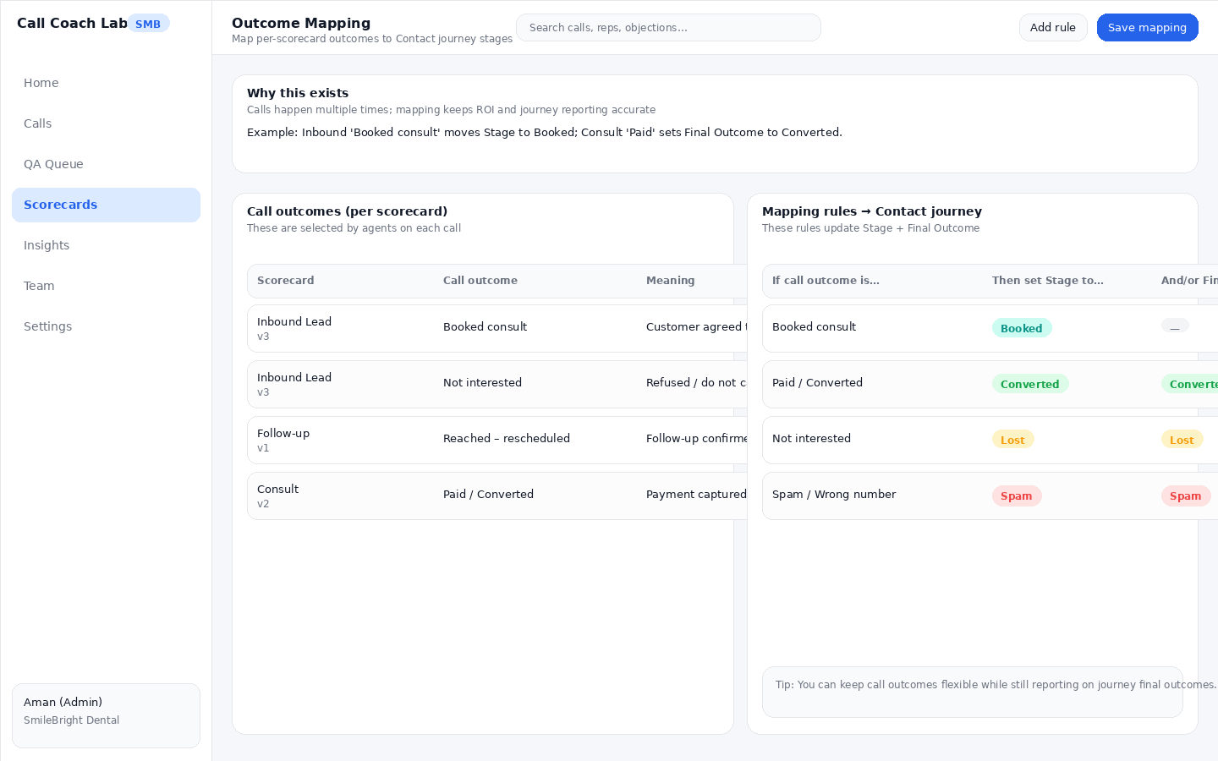
Outcome Mapping — keeps reporting correct across multi-call journeys.

5) Manager Journey — Priya and the ‘I can’t listen to everything’ problem
Priya doesn’t want a dashboard. She wants a daily workflow that improves bookings.

Scene M1 — Calls Inbox (triage + search)
Managers search, filter, and open specific calls. Calls Inbox shows score, outcome, flags, and top misses so Priya can pick what matters.
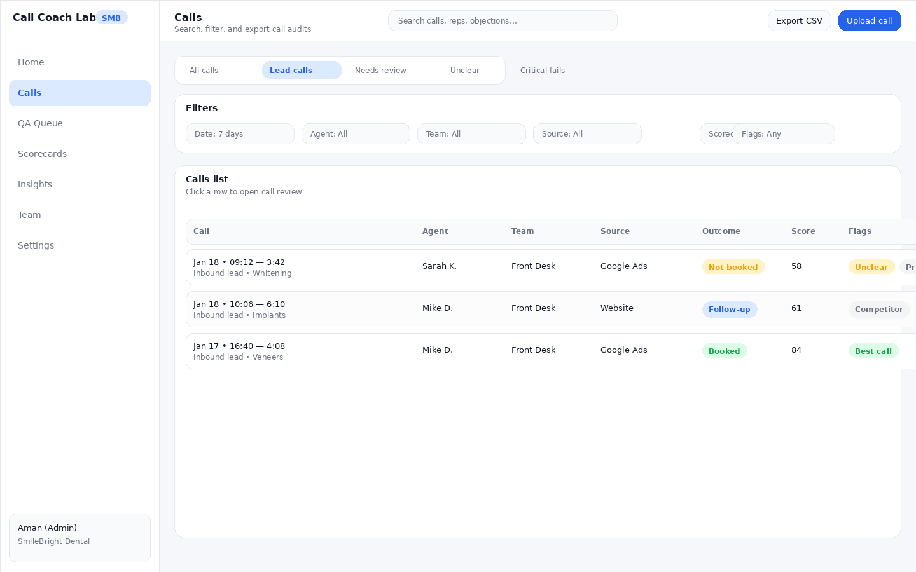
Calls Inbox — filters + flags + one-click open.

Scene M2 — QA Queue (what Priya opens every day)
QA Queue is prioritized: lowest scores, unclear, critical fails, new reps, random samples, trigger terms.
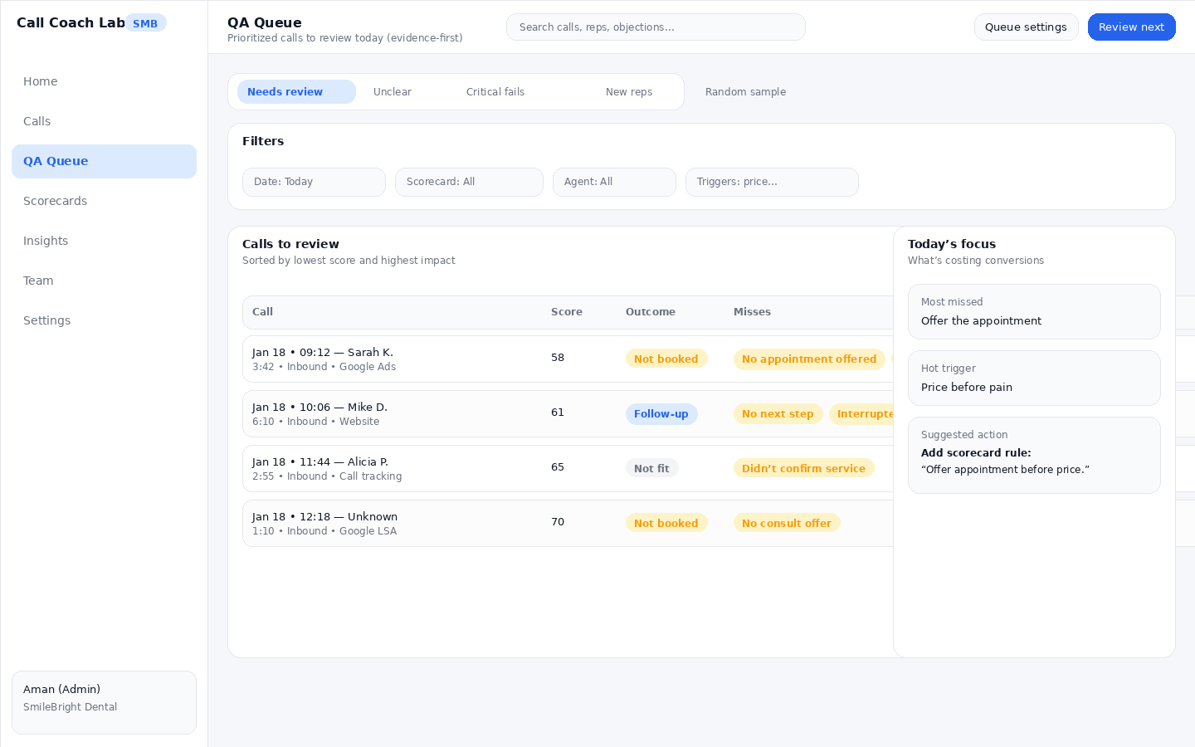
QA Queue — prioritized call review list + focus panel.

Scene M3 — Call Review (evidence-first)
The call review screen must make it easy to prove: “here’s exactly where it happened.” Every criterion shows pass/fail/unclear + confidence + evidence timestamp.
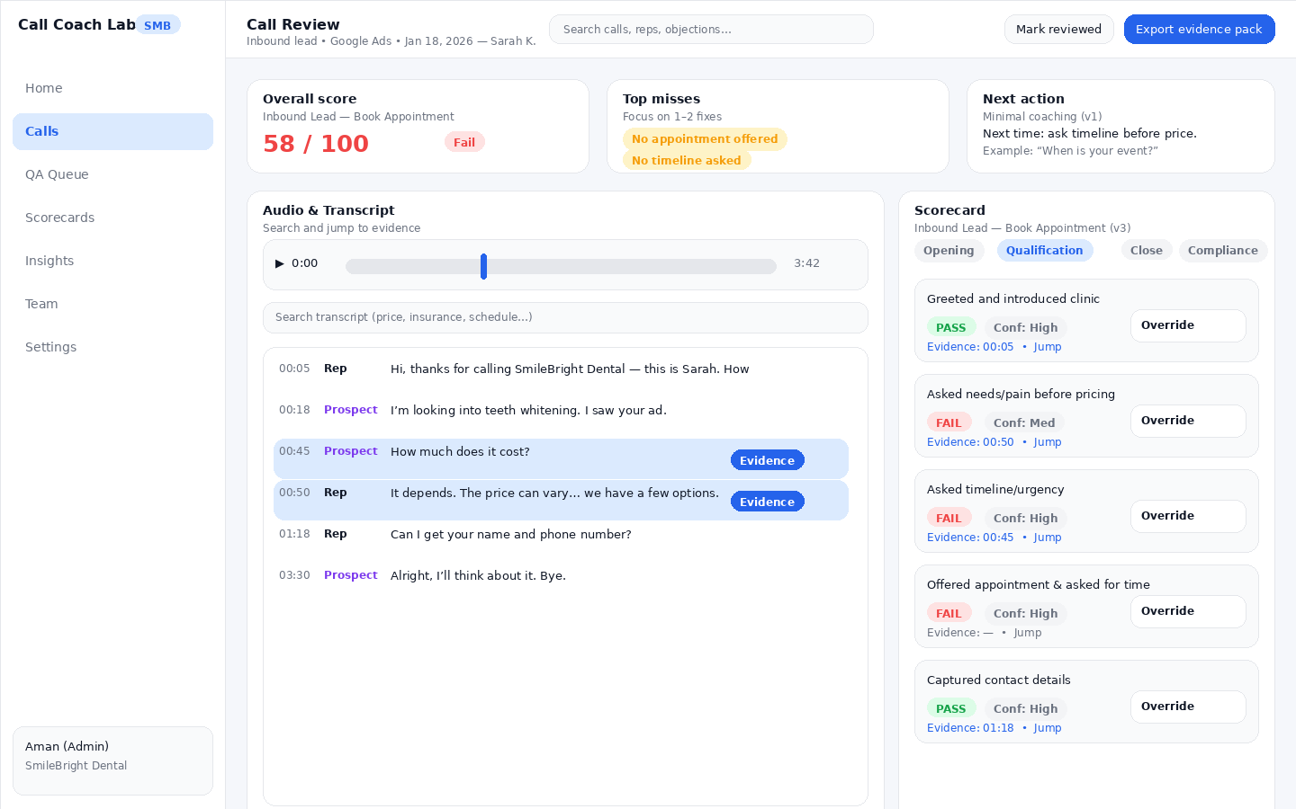
Call Review — synced audio + transcript + per-criterion scoring with evidence.

Scene M4 — Exports: Evidence packs (shareable)
Managers can export PDF evidence packs and generate share links with expiry (useful for agencies and owner updates).
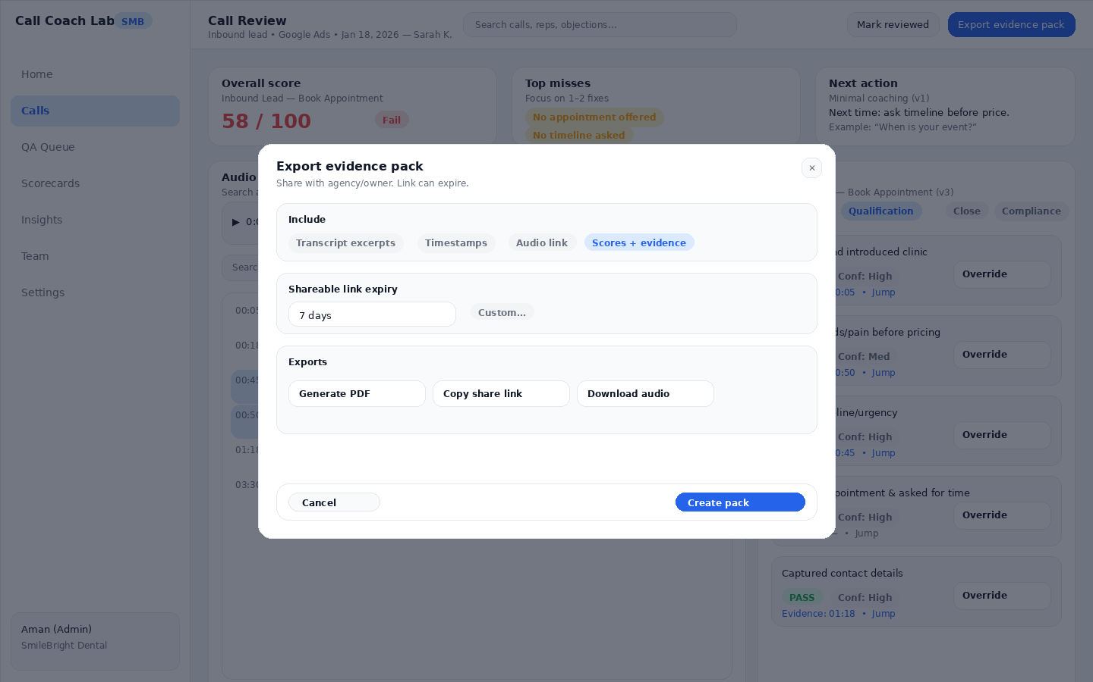
Evidence Pack Export — PDF, share link with expiry, CSV/audio/CRM note options.

Scene M5 — Insights: Marketing ROI + QA Trends + VoC
In v1, ROI is quality-adjusted trends by source/channel (no cost required). QA Trends show variance, misses, and progress. Voice of Customer groups objections and lost reasons to drive playbook improvements.
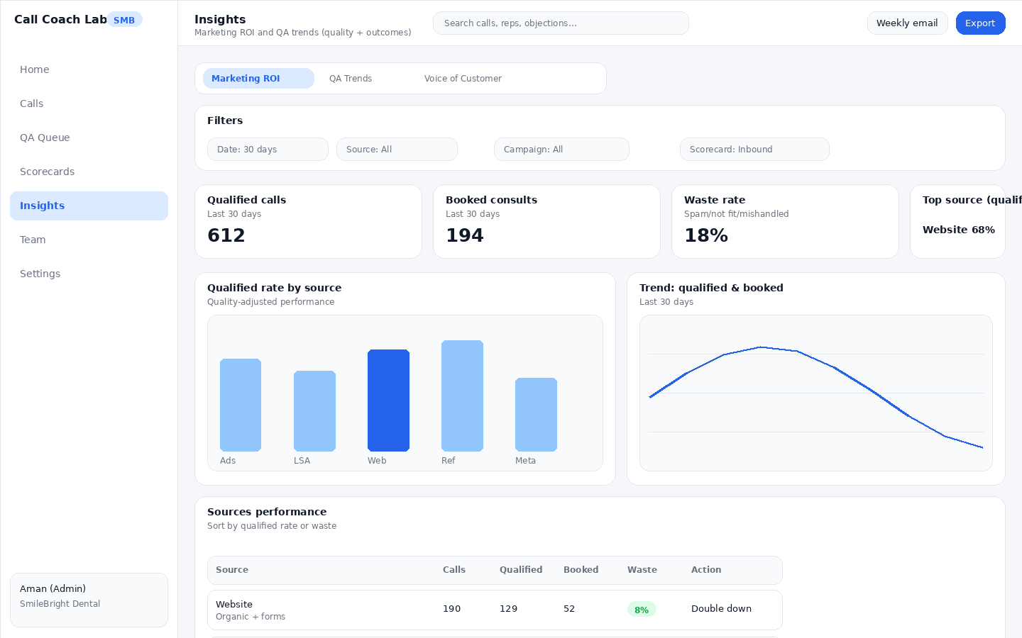
Insights — Marketing ROI by source/channel.
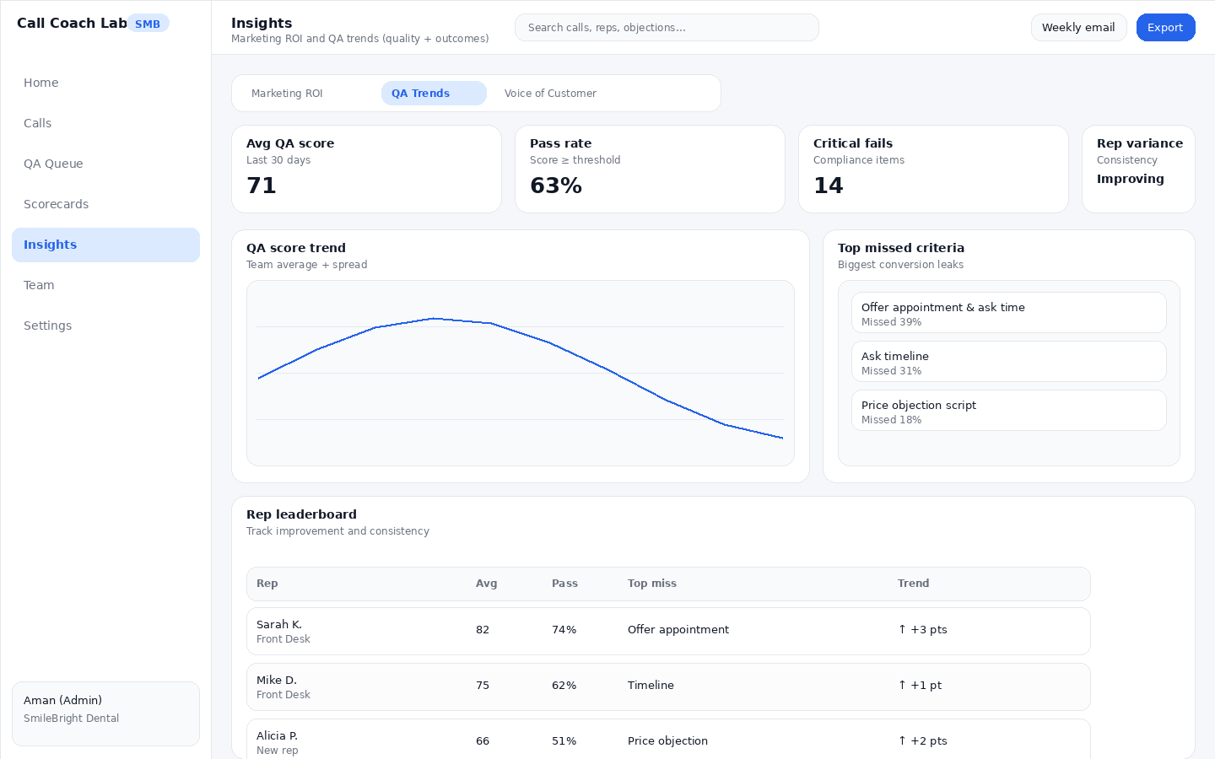
Insights — QA Trends: score trends, top misses, leaderboard.
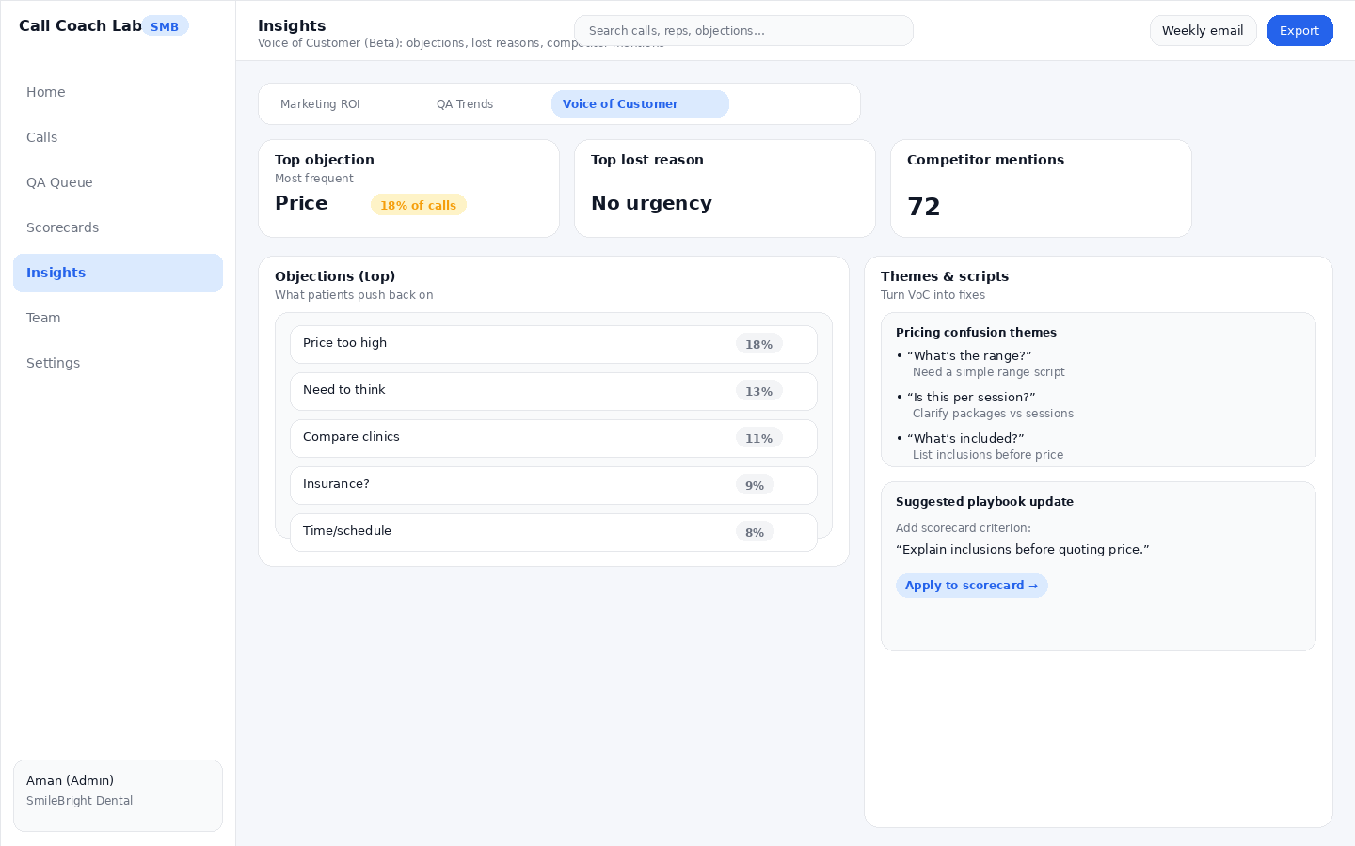
Insights — Voice of Customer: objections, themes, suggestions.

Scene M6 — Team page (standardization engine)
Team page gives Priya a high-level view of performance + pending acknowledgements + coaching opportunities.
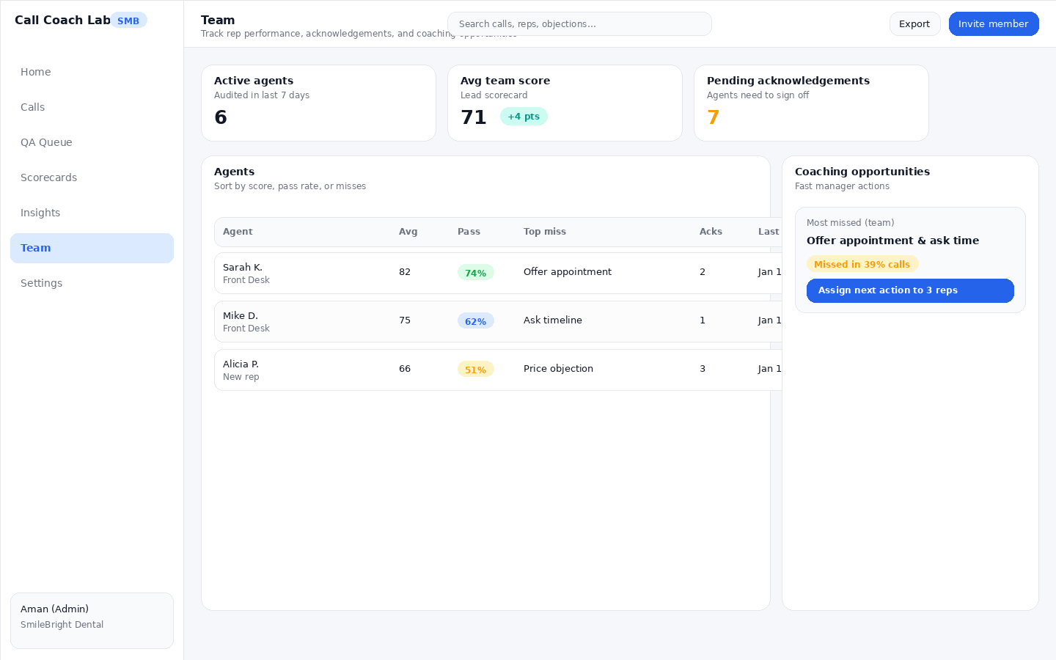
Team — rep performance + coaching actions.

6) Agent Journey — Sarah wants fair feedback and one next step
Agents improve when feedback is specific, fair, and fast. V1 gives one next action per call and allows clarification requests.

Scene S1 — My Evaluations (agent inbox)
Evaluations list shows score, top misses, and the one next action. Agents acknowledge evaluations to close the loop.
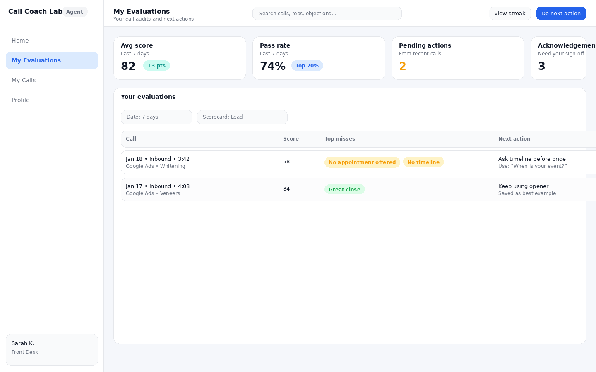
Agent — My Evaluations list.

Scene S2 — Evaluation Detail (evidence + clarification)
Evaluation Detail shows evidence clips and breakdown per criterion. Agents can request clarification if scoring missed context.
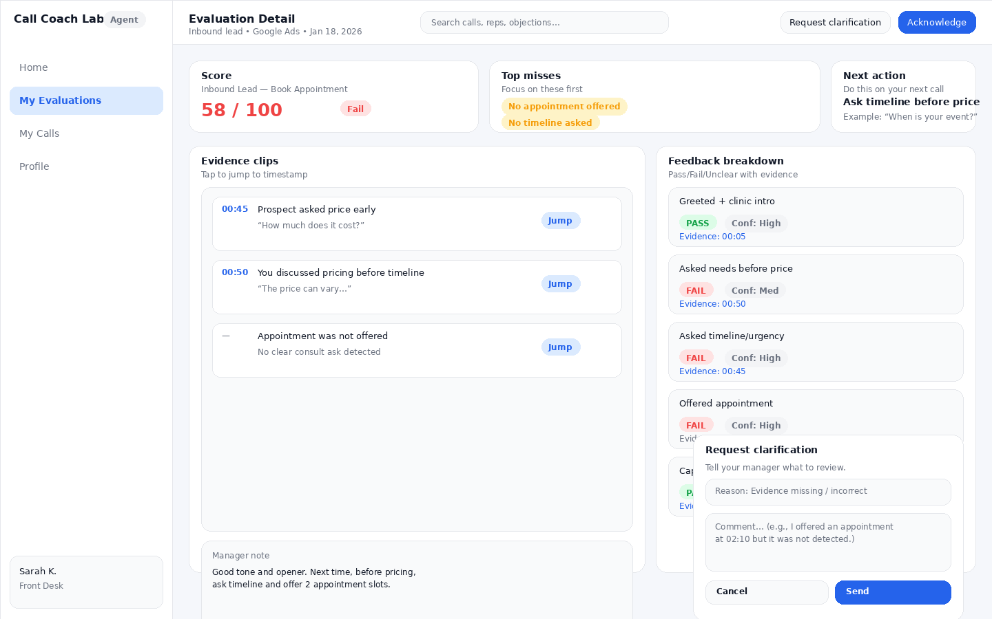
Agent — Evaluation Detail with clarification modal.

7) Contact Journey — because customers don’t convert in one call
The same number can call multiple times: inbound lead → follow-up → consult → conversion. Contact Journey links these calls so reporting doesn’t lie.
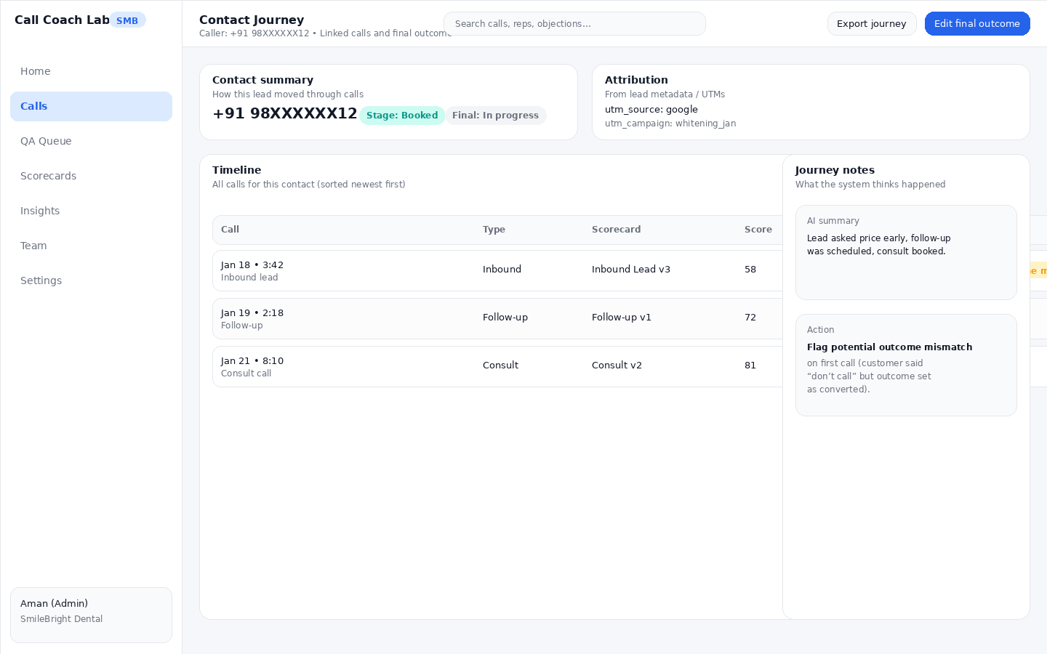
Contact Journey — timeline of calls + final outcome + attribution.

8) Edge cases library (how reality tries to break the product)

Ingestion failures
- Corrupted/unsupported audio → show failure reason + retry.
- CSV filename mismatch → row-level error + fix suggestion.
- Unknown agent → ingest but mark ‘Unassigned agent’ and allow mapping.
- Partial success processing (do not block the entire upload).

Scoring weirdness
- Allow ‘Unclear’ instead of forcing pass/fail.
- Show confidence (low/med/high) and route low-confidence calls to QA Queue.
- Multi-language transcripts may mix languages in a single call — search must still work.

Outcome mismatches
- Agent sets outcome; system flags suspicious mismatches.
- Manager can request correction; optionally override if admin allows.

9) Definition of Done for v1
- Upload + CSV works (bulk) with validation, partial success, retries.
- Exotel + Twilio integrations ingest recorded calls automatically.
- Transcription + scoring results visible within 5 minutes for typical calls.
- Scorecards: templates + builder + draft/publish + multiple scorecards.
- Automated scoring: pass/fail/unclear + confidence + evidence timestamps.
- Manager workflow: QA Queue + call review + overrides + one next action.
- Agent workflow: evaluations list + detail + acknowledge + clarification request.
- Outcomes: per-scorecard outcomes + contact-level final outcomes + mapping rules.
- Contact Journey page links calls by phone number and supports final outcome tracking.
- Insights: source/channel trends, QA trends, Voice of Customer basics.
- Exports: PDF evidence pack, shareable link with expiry, CSV export, audio download, CRM-note copy block.

10) Build To‑Dos (summary)

Design team (v1)
- Finalize IA + role-based navigation (Admin/Manager vs Agent).
- Design Contact Journey + Attribution Import + Outcome Mapping + Agent Mapping table screens.
- Design empty/loading/error states for ingestion, transcription, scoring, exports.
- Define micro-interactions: jump-to-evidence, override scoring, clarification flow, outcome mismatch warnings.
- Produce clickable prototypes for: QA Queue → Call Review → Send next action → Agent acknowledges.

Engineering team (v1)
- Build ingestion pipelines: Upload+CSV, Exotel, Twilio (recorded calls only).
- Implement processing pipeline: transcription (multi-language), diarization, scoring, evidence extraction, <5 min SLA.
- Implement rules engine for QA Queue + triggers + random sampling + new rep logic.
- Implement outcomes + contact timeline linking + mapping rules + mismatch detection.
- Implement exports: PDF evidence pack, share links (expiry + revoke), CSV export, audio download, CRM note block.
- Instrument metrics: ingest success, scoring SLA, unclear rate, override rate.
Next: See ‘Build Backlog & Acceptance Criteria’ (Doc 2) for the detailed screen-by-screen build plan.

